**Software Process Selection and Project Plan**

**P01:Petswala**

**<team member names & ids>**

|  |  |
| --- | --- |
| **Student ID** | **Name** |
| **22100098** | **M. Ibrahim Bhalli** |
| **22100200** | **Muhammad Tayyab** |
| **22100300** | **Muhammad Aaish Javed** |
| **20100049** | **Syed Raza Abbas** |
|  |  |

|  |  |  |
| --- | --- | --- |
| **Content** | **Totals** | **Obtained** |
| Software Process Selection | 25 | 25 |
| Project context analysis | 10 | 4 |
| Gantt chart | 25 | 18 |
| Development environment preparation | 20 | 20 |
| Deployment platform | 10 | 10 |
| Who did what | 3 | 3 |
| Review checklist | 2 | 2 |
| Overall formatting/template | 5 | 5 |
| Late submission penalty | -20 |  |
| **Total** | **100** | **87** |
| Review | 20 |  |
| **Grand Total** |  |  |

**Table of Contents**

1. Introduction 3

2. Software Process Selection 4

3. Gantt Chart 5

4. Risk Management 5

4.1 Potential Risks and Mitigation Strategies 5

5. Development Environment Preparation 6

6. Deployment Platform 6

7. Who Did What? 7

8. Review checklist 7

# Introduction

<Give an overview of the project here. The overview must highlight the overall objectives of the project and its potential users and customers.>

Petswala is an online web-based platform for pet owners. Our product aims to provide pet owners and others in the veterinary or pet service industry with an online platform where both service providers and customers can interact and engage in commerce.

The document will provide an overview of what our web application would offer, including but not limited to its functionalities, constraints, assumptions and dependencies.

We will be developing a web application which registers pet owners, vets, other pet service and accessories providers and possibly pet experts and allows them to interact based on their needs. For instance, pet service providers and vets would be able to advertise their services and products and pet owners would be able to contact these service providers as well as connect with other pet owners for any purpose such as breeding, purchasing or selling.

As mentioned earlier, potential users of the web-application will be key characters in the pets’ communities:

· Pet owners

· Service providers

· Rescue Services

· Vets

· Pet Buyers

· Pet Sellers

· Business administrators

# Software Process Selection

< (1) Discuss pros and cons of waterfall and agile (scrum) processes in your own words.

(2) Select one of the above processes for your project development.

(3) Justify your selection with clear reasoning. Refer to “Project Context Analysis” in the slides to get help for writing this section.>

Waterfall Model: Pros and Cons

|  |  |
| --- | --- |
| **Pros** | **Cons** |
| Spend more time and effort on the preceding phases to mitigate errors in the succeeding phases | Responding to unstable customer requirements can be hard due to the nature of the development lifecycle in waterfall model |
| Enforces discipline and time scales are adhered to | More suitable for large systems engineering projects |
| Since the end result is planned and document, the outcome of the project is explicitly clear | Functional system only results late into the development lifecycle |
| Financial requirements can accurately be estimated due to predefined outcomes | Longer delivery time |
| Emphasis on documentation which helps plan better | Client/end user involvement in the project is minimal |

Agile(SCRUM) Model: Pros and Cons

|  |  |
| --- | --- |
| **Pros** | **Cons** |
| Project deliverables can be completed quickly and efficiently. | Prioritizing changes in case of multiple stakeholders can be challenging |
| Very responsive to changing user requirements. | Scrum master must be keeping meeting productive and everyone in check, and team members must communicate properly |
| Team members have more freedom with their developmental responsibilities as long as they meet team goals | Usually results in a lack of documentation |
| Large projects are divided into easily manageable sprints | Adopting SCRUM for larger teams is challenging |
| Team gets clear visibility through scrum meetings | May result in scope creep due to lack of a definite end-date |

[There were more aspects that you should have discussed. These aspects are mentioned in the “Project Context Analysis” slide.]

We will be using the agile scrum model for our developmental process. We have a small team of 4 and we believe that scrum will help us collaborate better and be more productive. As developers, it will be easier for us to break down the problem into small manageable chunks that we can deliver on time. Scrum proves very suitable for this as daily scrum meetings will minimize procrastination and ensure the team stays on track. Scrum meetings will enable us to have defined goals for everyday and since a progress report is due on the next day, it will keep us accountable. The team does not have the same developmental experience, and scrum will help us learn and work together better since there is relatively more freedom with the developmental responsibilities in scrum. We believe it’ll be better to work in sprints and see results sooner, instead of trying to develop the entire project in one go. Scrum will help us implement different subsystems and modules as sprints. We can work on adjusting our project requirements and scope as our abilities and skills improve. Scrum will help us develop a system that is receptive to stakeholder feedback. Sprints will regularly enforce deadlines on us which will urge us to work harder and be productive instead of slacking off.

# Gantt Chart

<Draw a Gantt chart that illustrates your project’s schedule. The Gantt chart should show at least the following

* Tasks (tasks should not be too small or too large)
* Duration (in weeks)
* Milestones
* Team member names who are going to work on each task.

[There are some tasks on which the whole team can work together. However, there are others which needs to be divided. For instance, coding tasks.]

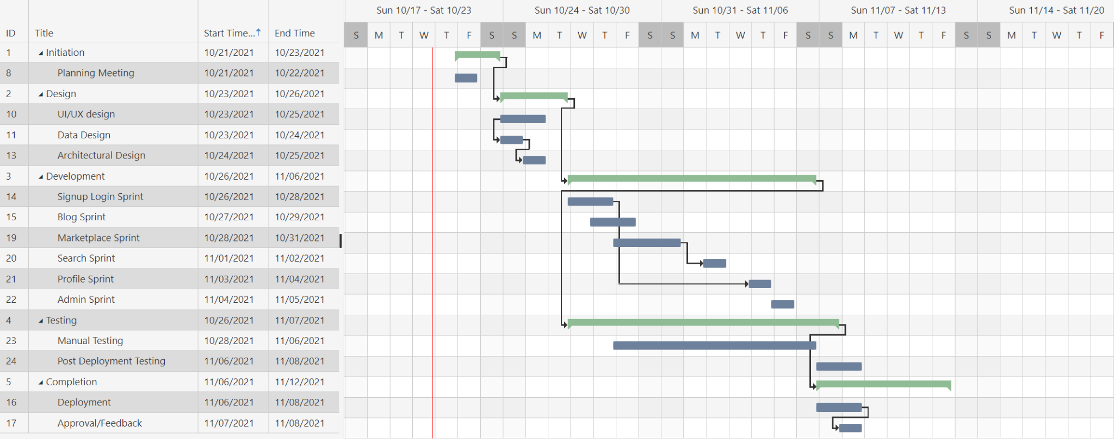

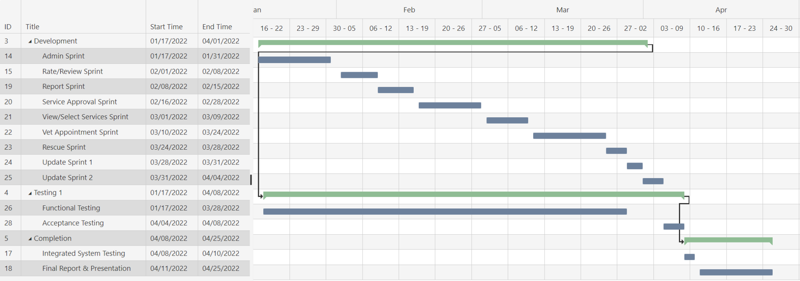

The team members will be contributing equally to each task. This is in accordance with SCRUM philosophy. However, on a higher-level, team members will be specializing as follows,

* Muhammad Ibrahim Bhalli - Backend Development, SCRUM Master
* Muhammad Aaish Javed - Backend Development, UI-UX
* Muhammad Tayyab - Frontend Development, UI-UX
* Syed Raza Abbas - Frontend Development, UI-UX

# Risk Management

## Potential Risks and Mitigation Strategies

<List down top 10 potential risks and their mitigation strategies>

|  |  |  |
| --- | --- | --- |
| **Sr.** | **Risk Description** | **Mitigation Strategy** |
|  | Procrastination | Having scrum meetings daily and not delaying the project deliverables |
|  | Lack of developmental skill | Team members will work together on the developmental process, collaborating and learning together instead of having defined developmental roles |
|  | Lack of availability of team members | In case a team member is unavailable in case of emergency the other team members will make up for his deficiency provided that the team member makes up for it later. |
| 4. | Breach in user credential security | Make use of secure frameworks that ensure strong encryption and multiple verification techniques and steps. |
| 5. | Risk of losing to competitors | Designing and executing a proper marketing plan, innovating and improving services to customer satisfaction. |
| 6. | Database performance does not keep with the demand on the system. | Investigate the possibility of investing in a higher performing database. |
| 7. | Risk of client not liking the end product and requesting for change in functional requirements | Scrum method will be used to ensure frequent reviews from the client during development. Requirements will be revisited and understood in a back and forth manner. |
| 8. | Poor quality code | Team members will collaborate and review code, seek advice on supervisors and do code reviews in order to improve code. Code will also be well documented and commented so that future expansion and maintenance of code is made feasible and convenient. |
| 9. | Technical difficulties | If the team cannot solve a problem then they will do extensive research online and seek expert advice/guidance. |
| 10. | Poor management | The teammates will keep each other in check. The supervisor will be monitoring progress and having bi-weekly meetings. Any conflicts within the team (if not resolved) will be forwarded to the supervisor. |
| 11. | Serious conflicts on blog | Providing explicit community guidelines with regard to blog posts and using monitoring and controlling techniques to maintain a safe environment free of religious, political and any other irrelevant debate. |
| 12. | Scams and low quality products | Implementing a return policy for products and strict background checks during service registrations. |

# Development Environment Preparation

< (1) List down tools and technologies that you will use for prototype development.

(2) Setup the development environment on your machines and mention here that you have actually set up the environment. Include three snapshots of the tool(s) that you are going to use for development. These snapshots must be taken from the tool(s) while they are actually running on your system.>

We will be using the following tools and technologies for our prototype development:

1. Visual Studio Code / Sublime Text

This is where most of the development will be done. Almost all of the coding will be done using these tools.

1. Google Chrome and Chrome Developer Tools

It will be used for running our prototype, and the developer tools will help us inspect and analyze our code in real time.

1. Codepen (TENTATIVE)

Might be used to help with front end development

1. Bootstrap

It will be used in front end development in HTML files

1. Git and Github

It will be used for collaboration between the team members and version control

1. Trello

It will be used for project planning and task delegation

1. Django and Python

It is a web development framework written in python

1. PostGres / SQLite

This will be the database of our prototype

1. Amazon Web Services (AWS)

It will be used for hosting the website

1. Zoom

It will be used for online scrum and project meetings

**Screenshots**

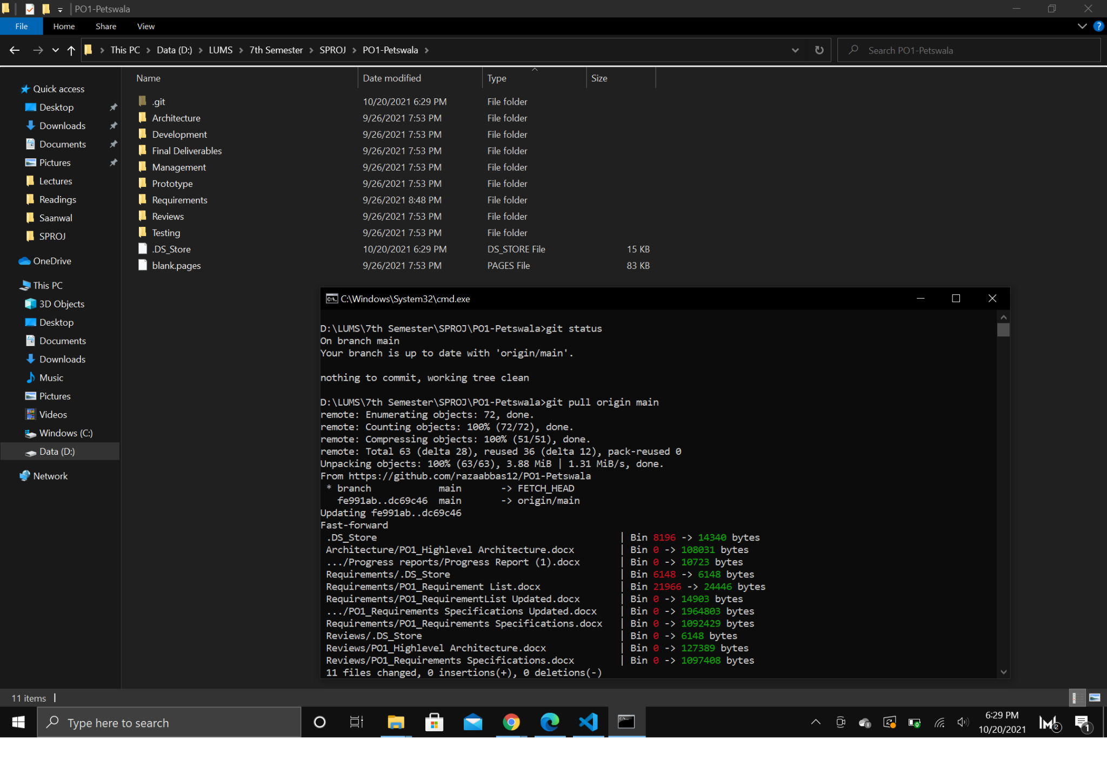

**(Git)**

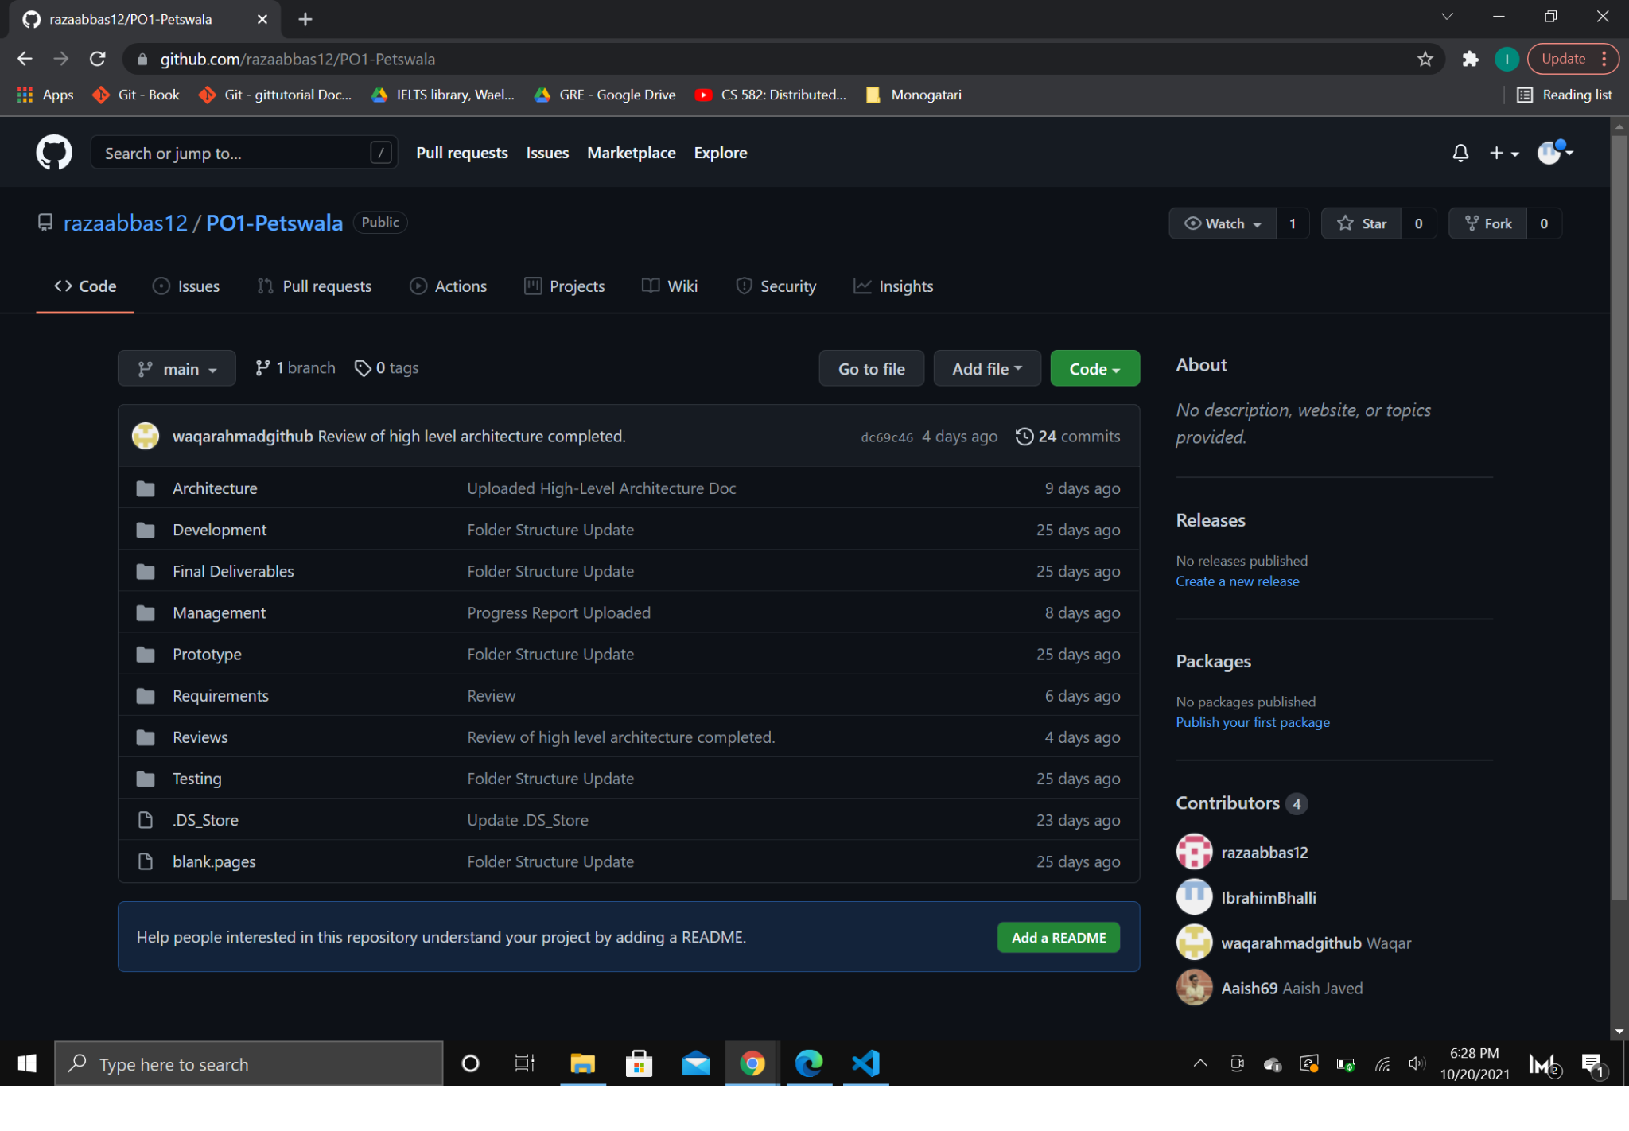

**(Github)**

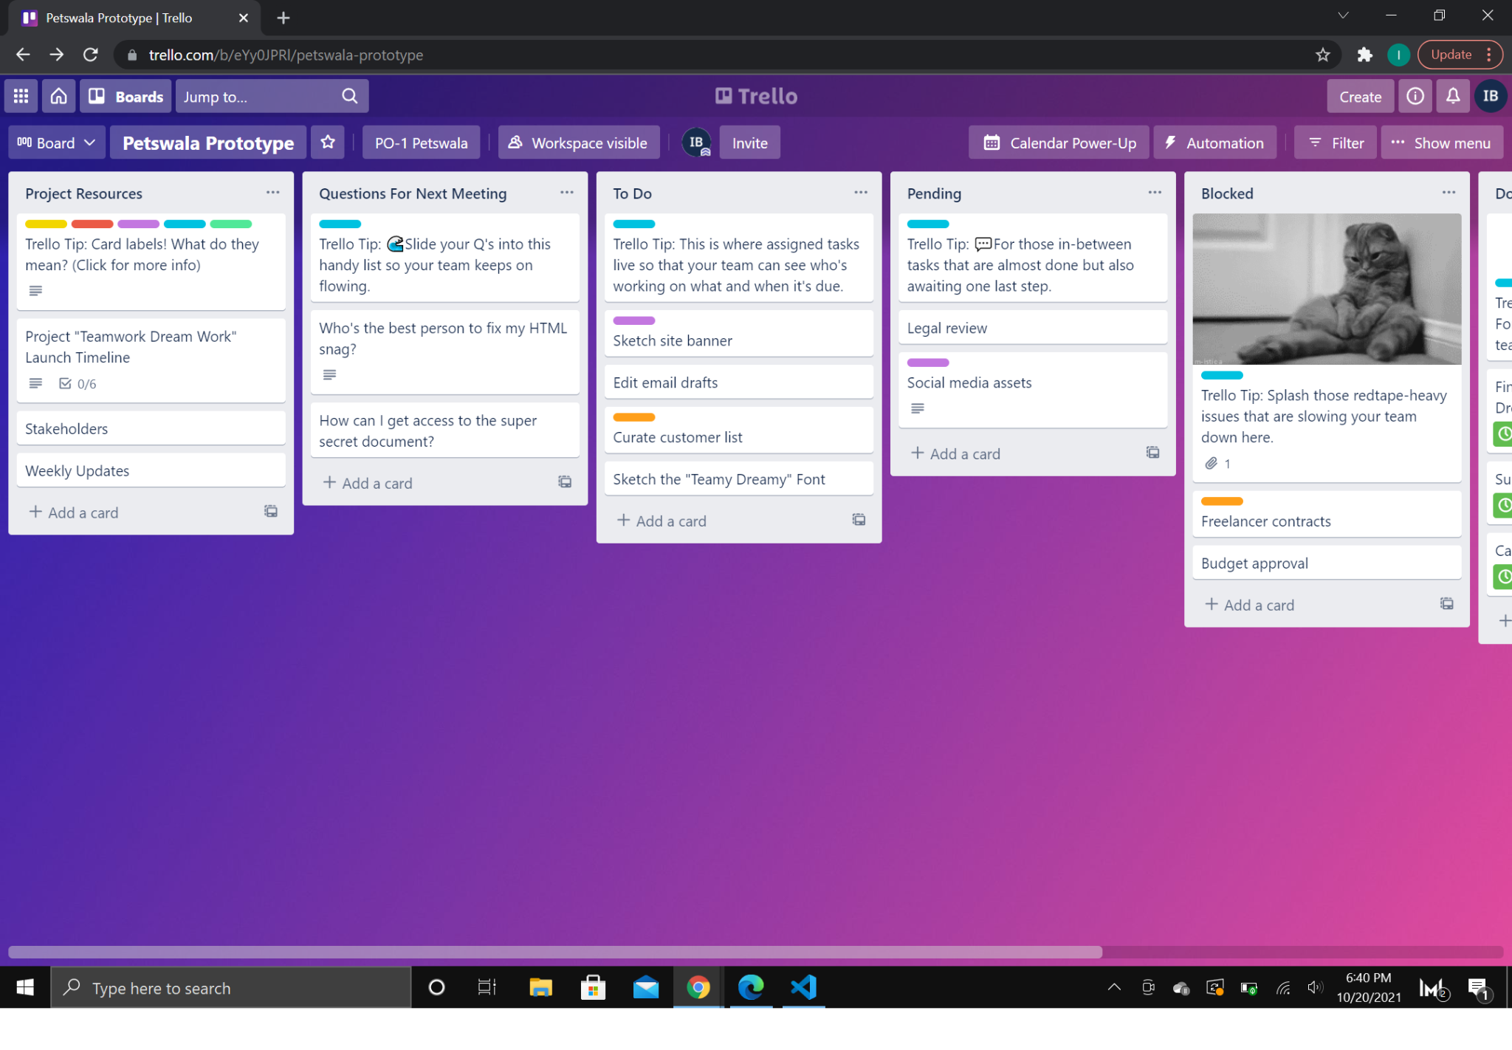

**(Trello)**

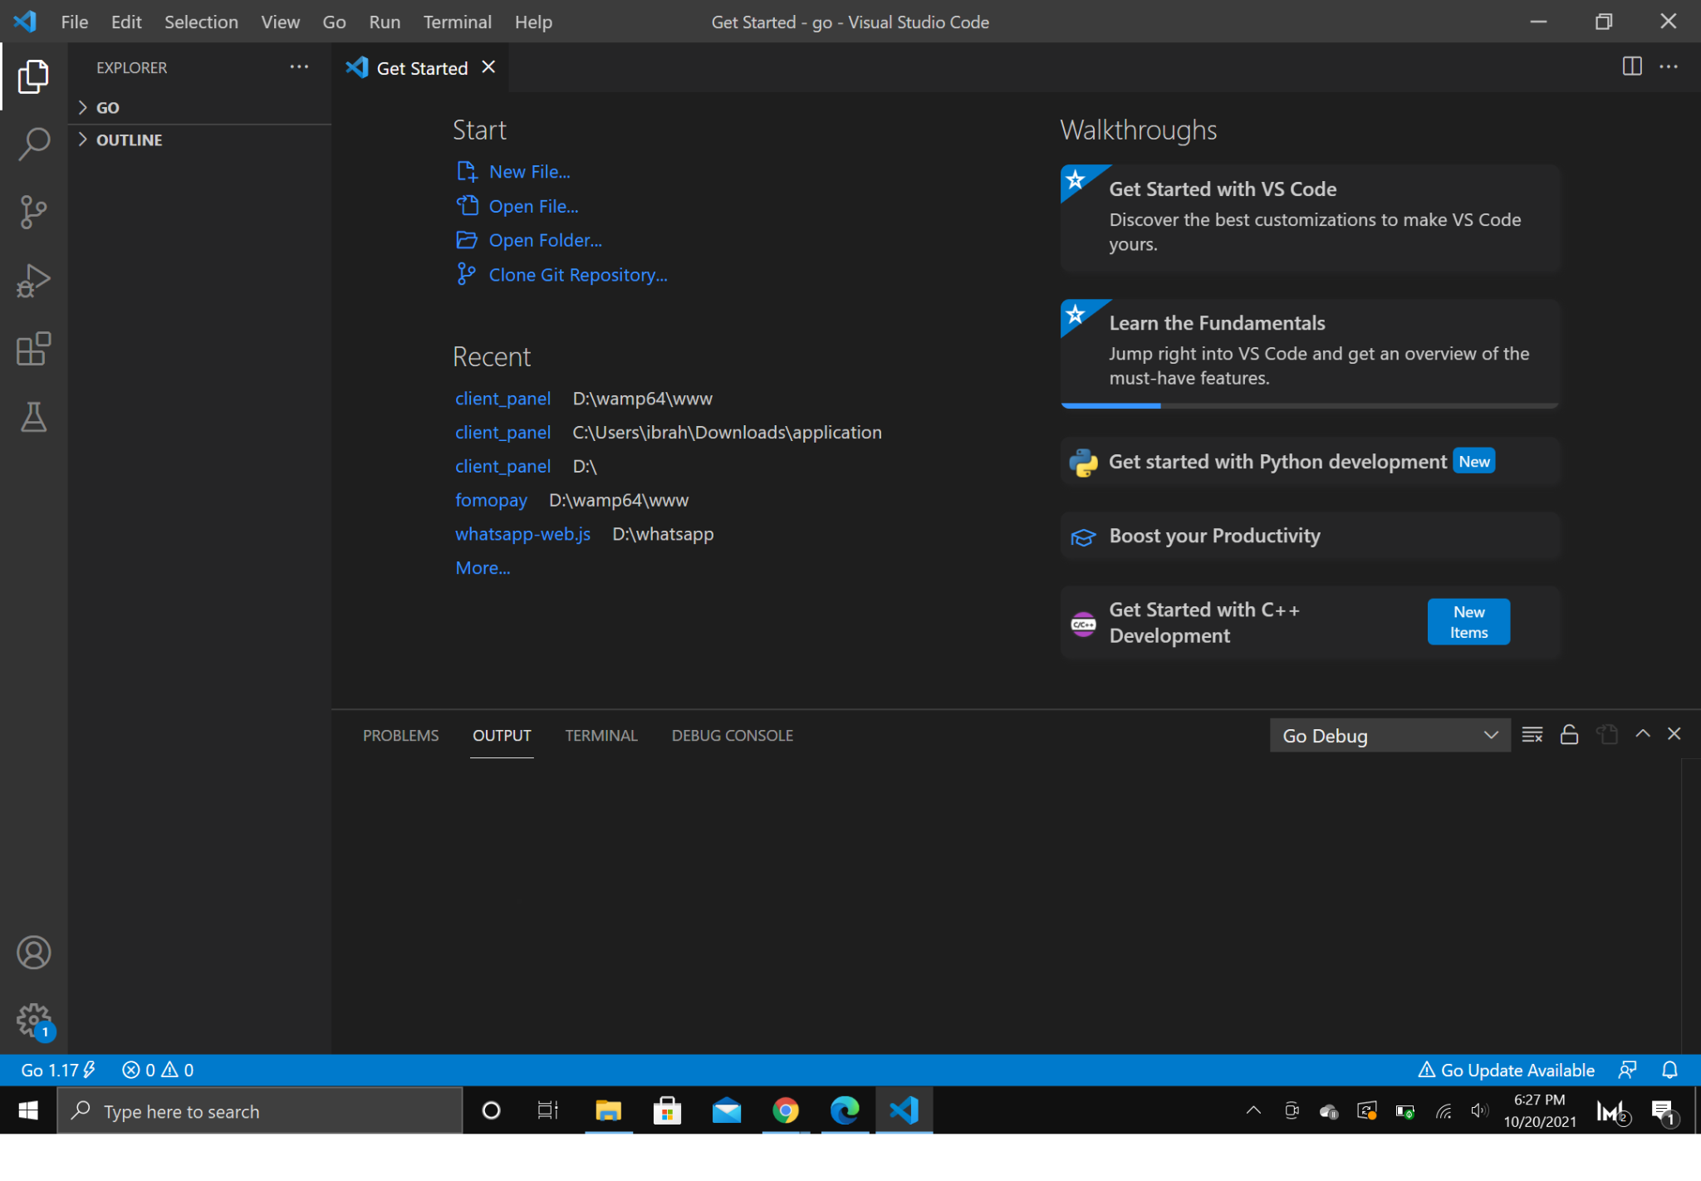

**(Visual Studio Code)**

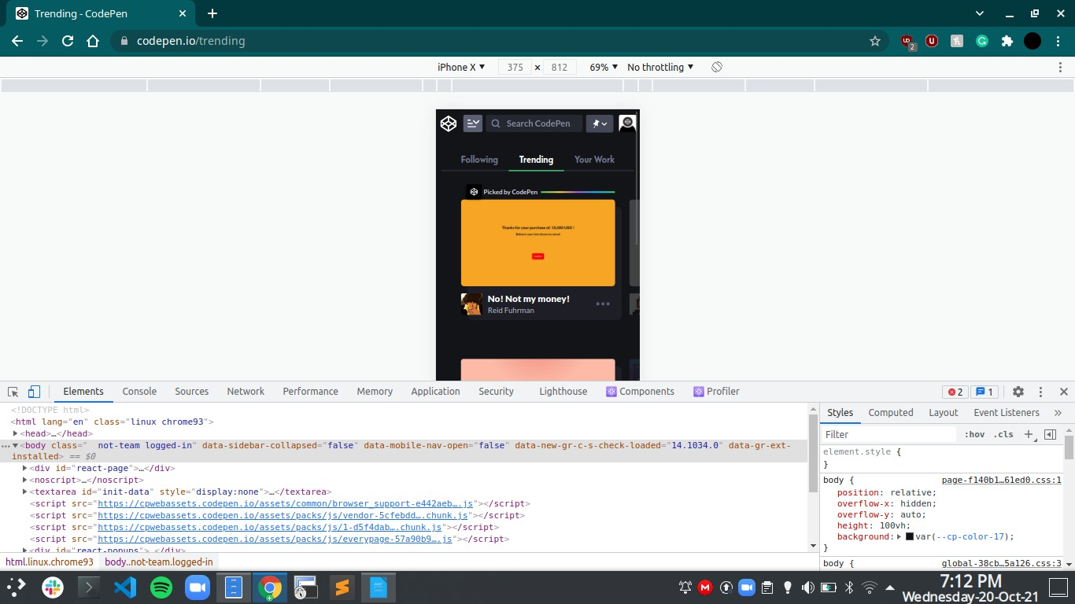

**(Google Chrome & Chrome Developer Tools)**

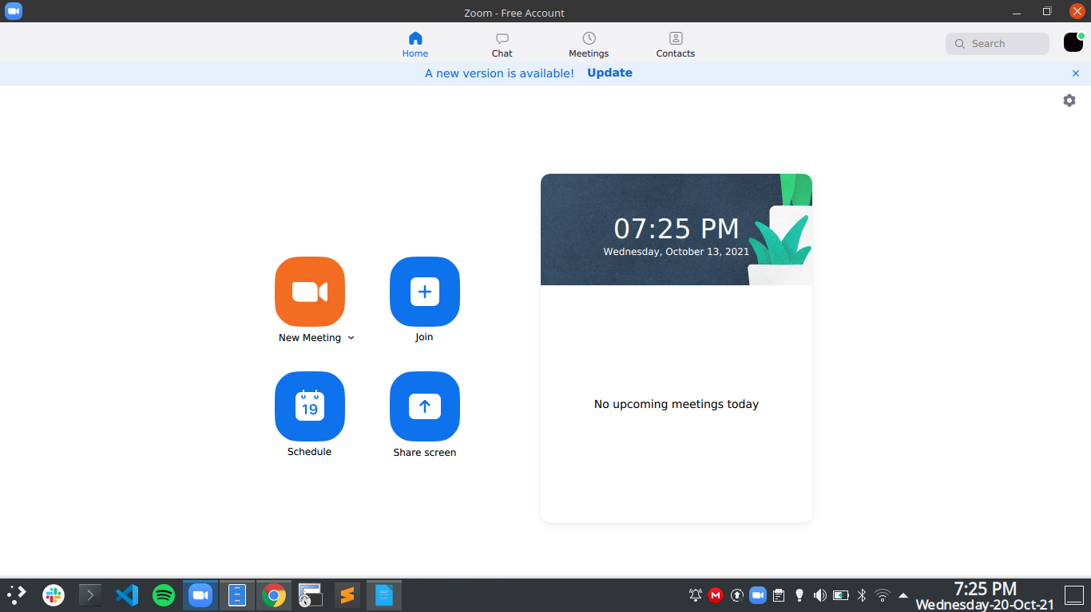

**(Zoom)**

# Deployment Platform

<Find a free hosting service where you can deploy your prototype for anyone to access online>

We will be using the minimum Free Tier package offered by AWS to host our website,

which provides the following services.

* 25 GB of Storage
* 25 provisioned Write Capacity Units(WCU
* 25 provisioned Read Capacity Units(RCU)
* Enough to handle up to 200M requests per month

(These specific requirements are based on the minimum Free Tier package offered by AWS)

# Who Did What?

|  |  |
| --- | --- |
| **Name of the Team Member** | **Tasks done** |
| Muhammad Ibrahim Bhalli | Introduction, Software Process Selection, Gantt Chart, Risk Management, Development Environmental Preparation,  Deployment Platform |
| Muhammad Aaish Javed | Introduction, Gantt Chart, Risk Management, Developmental Environmental Preparation, Deployment Platform |
| Muhammad Tayyab | Development Environmental Preparation, Risk Management |
| Syed Raza Abbas | Risk Management, Introduction |

# Review checklist

Before submission of this deliverable, the team must perform an internal review. Each team member will review one or more sections of the deliverable.

|  |  |
| --- | --- |
| **Section** **Title** | **Reviewer Name(s)** |
| Risk Management | Muhammad Ibrahim Bhalli, Muhammad Aaish Javed |
| Software Process Selection | Muhammd Aaish Javed, Muhammad Tayyab, Muhammad Ibrahim Bhalli |
| Gantt Chart | Muhammd Aaish Javed, Muhammad Tayyab, Muhammad Ibrahim Bhalli |
| Development Environment Prep | Syed Raza Abbas |
| Introduction | Syed Raza Abbas |